**Defects:**



**1**. Unable to Signup for the application. Not receiving Email - Fixed.

2. Not receiving any phone notification on signing up - Fixed

3. Header repeated – Fixed



4. Feature List – Text – linesrespond.

5. Feature List – Hierarchy dropdown- sentence correction.

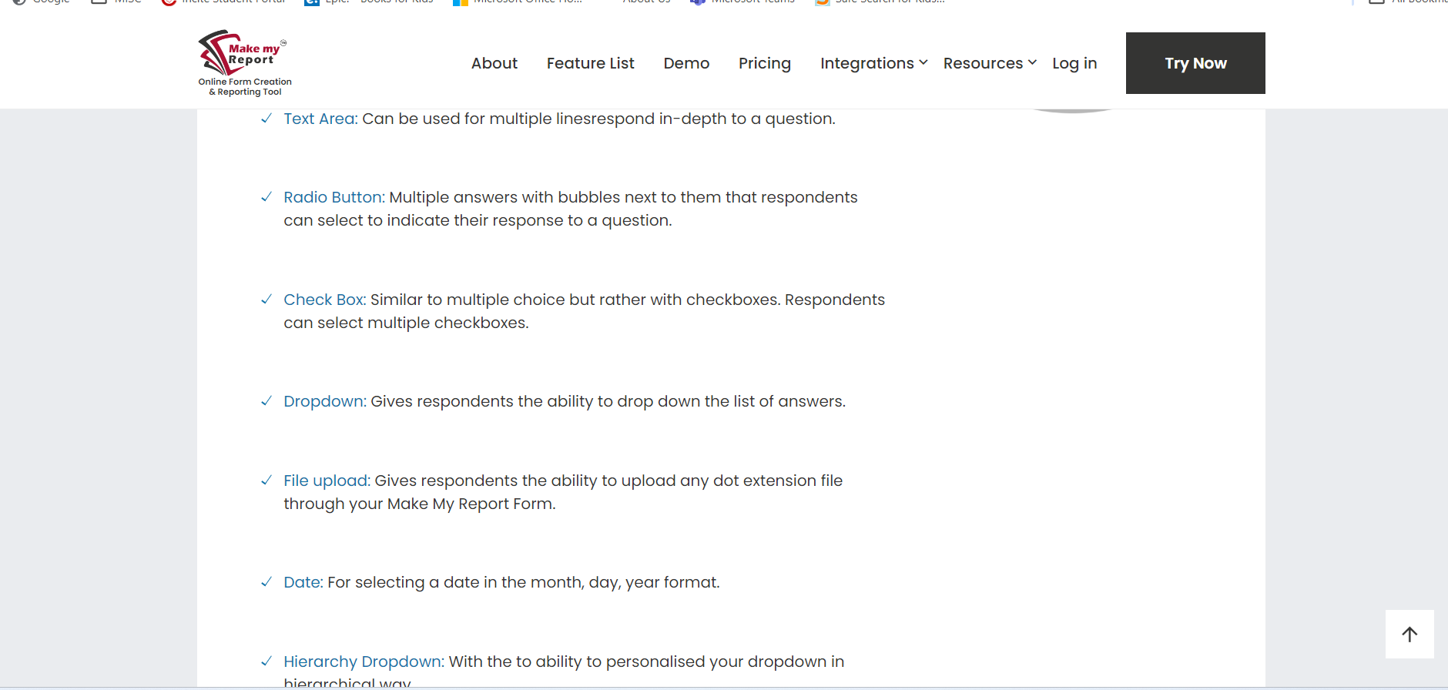



6. Free Signup is better than Try Now and then “Try for Free” text – just a suggestion.

7. Demo – Correction in text – a report, e-forms, requirements.



8.The dropdown button not working. The text part is.



9. Signup Failed when you go for Pay Now.

10. Resources – Correction to be made in sentences.



11. Getting error while deactivating a contact - Fixed

12. The “Group” Search filter for Contacts not working as expected. fixed



13. Error while resetting password of a contact.fixed

14. Login – Message displaying twice - Fixed

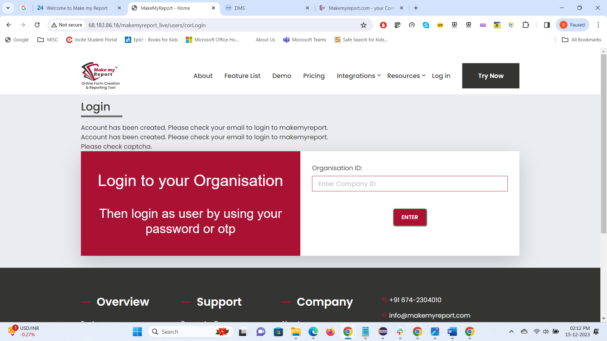



15. Login success or failure message not displaying.

16. Contacts – Bulk upload – Whatever group you assign and upload, it takes up a default group. If you don’t assign any Group, still it assigns a default group to the contacts. It should remain blank.

17. Contacts – Cannot select multiple contacts to assign one group.

18. Check the Dashboard contents - Only Create a Contacts tab and Create a Report tab is clickable. Rest all the tabs are disabled. – Rest of the tabs removed.

19. Why is there no Delete option to delete a contact.

20. MMR – Create a Report - Hover your mouse on the information icon "ii" on each field –

In the Number of Submission per Contact field information, "particular" spelling is written as “perticular”.

The information on the Access Type is wrong.

21. Report Edit – Even after making the Text Box compulsory, it is not showing the same in the preview but the red asterik is showing on the report. - Fixed

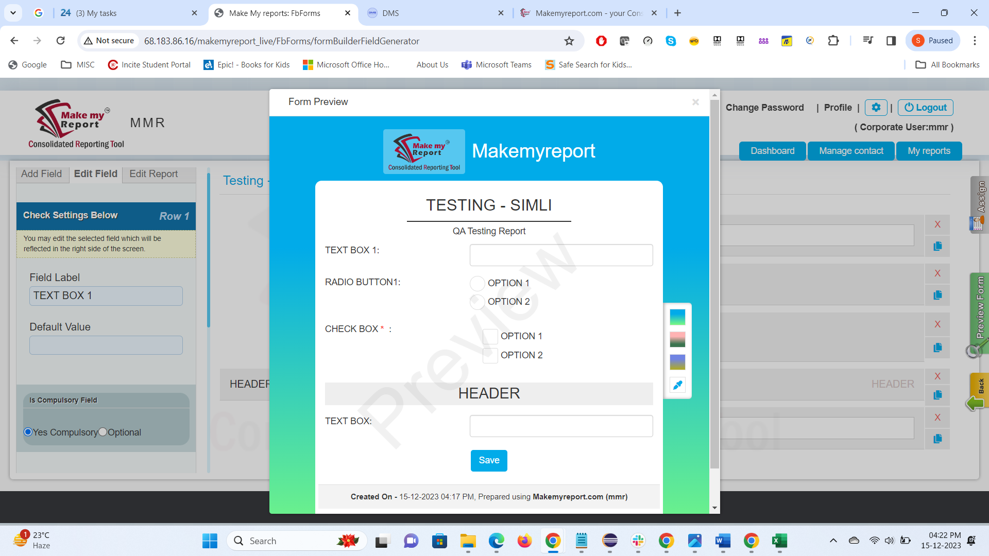



22. Edit Report – Hierarchy dropdown – Repetition. Dropdown not showing any options. - Fixed



23. In Assign to Contact the “Live Search” feature is not working.

24. Reset Password of a Contact – fixed

25. Contacts – There should be a multiple selection option to deactivate contacts. Say I want to deactivate contacts from a particular group and that group has bulk contacts – Suggestion.

26. When you hover your mouse on the highlighted area below, it says “Download Excel” and on clicking it takes you to the old MMR website.

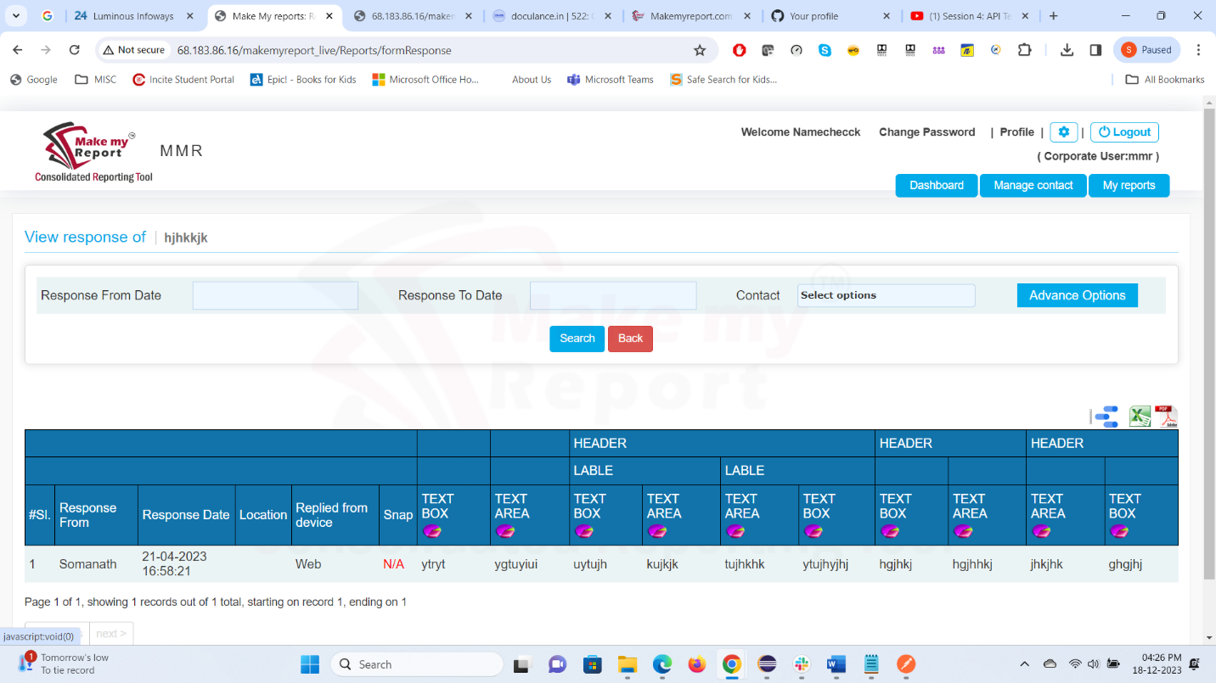



27. Archive Report – View Response – Download Excel & Download PDF-At the bottom of the table, the sentence looks wrong. It's written, "Created by : Simli , Corporate on making report(198018),On 2023-10-26 10:30:20"

Suggestion : MMR Report Created By: Simli, Corporate On 2023-10-26 10:30:20

28. Please make City names first letter caps.

29. Need Help Line? Remove “to”.

30. When creating big Reports with many fields, the first two fields are getting shuffled.

31. Spelling of “Customize” is wrong.



31. Date field in the below report is a mandatory field but it is disabled. Unable to submit the report.

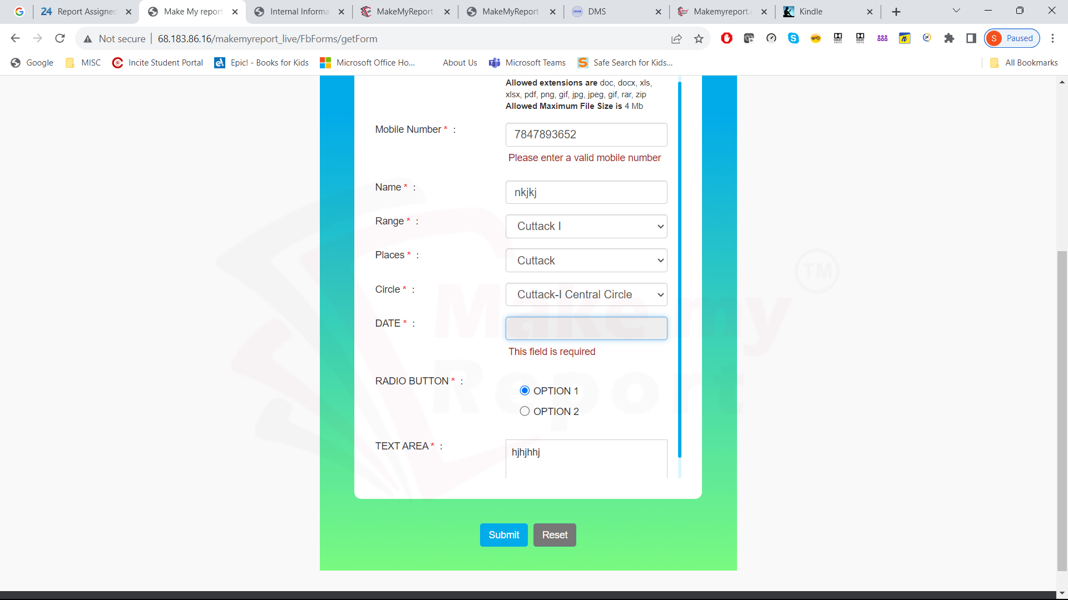

32. Two contacts of same email id and phone number exists.

33. The sample message needs correction.

“ We have arranged an office award ceremony. It would be nice if all our office staff participate in this special event and make it eventful!

Would you like to attend? Please confirm your availability by selecting from the options provided below.”

34. Manage Message – I am sending WhatsApp messages but an email is also being sent to the contacts with the dummy message and not the actual message.

In the Message List section, the Whatsapp message is getting displayed but for email the space remains blank.

35. Manage Message – Did not receive any message on Whatsapp.

1. Manage Message – Query based WhatsApp messages - No customization allowed here except image upload??
2. Manage Message – Query based WhatsApp message- What is this Import Excel about? Please specify.
3. Manage Message – Query based – Why Contacts list is not displayed here?
4. This “tick” confirmation is only shown for Email and Whatsapp 🡪 General 🡪 Interested category. I don’t see it for any other categories like Events, reply msg, etc.

1. Report Assigning to a contact is not working as expected.

The link received on message, on clicking did not open the report, instead I was taken to the MMR master page. And the link received on Whatsapp was not clickable.

I received notification on phone but I did not receive any email. Also the report in MMR showed as not assigned.